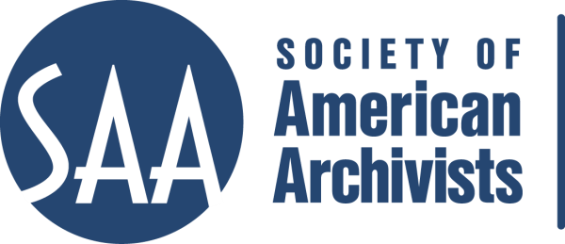
CE Workshop Evaluation Form
Arrangement and Description Track

Workshop Evaluation Form:

Title | Implementing DACS in Integrated Content Management Systems: Using the Archivists’ Toolkit
Reviewer: | Alison Clemens
Directions:
- Quantitative: Each item below begins with a bolded statement. Score each with a 1-5 ranking to indicate your assessment of the veracity of that statement based on your review of workshop overviews/agendas, evaluations, and other materials.
- Qualitative: In the comments section for each item below, please respond to the additional questions posed and any related issues that this workshop raises for you.
- Provide any additional assessments or comments not relevant to one of the specific, numbered areas in the space provided following the table.

Please place an “x” in the appropriate column, use 1=low, undesirable, to 5=high, excellent. |  |  | 1 | 2 | 3 | 4 | 5
1. Does the content appeal to its specified audience? Does it indicate specific categories of archivists and/or levels of expertise to assist potential participants in determining the workshop's relevance for them?  Comments: Yes; it does an excellent job of explaining the background necessary for the course. |  |  |  |  |  |  | X
2. To what extent does the subject matter reflect current archival practices and theory commonly accepted in the profession?  Comments: Still current, but of potentially diminishing relevance in the future, as more repositories move to ArchivesSpace. |  |  |  |  |  |  | X
3.. How relevant/appropriate are the teaching and delivery methodologies (lecture, video, PowerPoint, exercises, film, audiotape, discussion, simulation, case study, opportunities for in-course feedback, etc.) to the articulated goals and objectives, and to the content?"  Comments: Should provide students the opportunity to bring an electronic version of DACS for the course, rather than just print. The workbook is absolutely exemplary. |  |  |  |  |  |  | X
4. How workable is the time line or agenda for the course? Is there sufficient detail to indicate how the workshop will evolve? Does it allow sufficient time for active engagement between course participants and the instructor(s)?  Comments: Excellent. |  |  |  |  |  |  | X
5. To what degree does the list of assigned readings support the content of the proposal?  Comments: |  |  |  |  |  |  | X
6. Does the presentation support the Learning Outcomes in the descriptions?  Comments: Yes; excellent. |  |  |  |  |  |  | X
 | A&D Track Considerations
 | 1.Does this content bridge, enhance, and/or build on other workshops (If so, please name) | Yes, it explicitly builds on the DACS course. It also has the potential to enhance other A&D classes, including Arrangement and Description of Manuscript Collections and Managing Literary Manuscripts.
 | 2.Does this build on other workshops not on the list? | Archival Content Management Systems, and some potential tie-in with digital curation courses.
 | 3 Should this be part of the A&D Track? | Yes.
 | 4.Where would this workshop fall in the sequence of an A&D track? | It should be early in the sequence. Note, though, that this class is especially compelling because it provides both an introductory view of AT and the resources for further expertise.
 | Why? | Archival content management systems are a foundational component of the archival practice.
 | 5. What tier does this workshop fall in? (See attached tiers)
 | 6. Target Audience | Archival practitioners of all varieties.
 | 7. Is the suggested prior “experience/knowledge” appropriate? | Yes.
 | 8. Learning Outcomes:  Are they appropriate and/or relevant? | List of specific, measurable, and actionable outcomes that each person should be able to do (e.g. discuss, explain, evaluate, design) by the end of the course:  - Create accession descriptions; Yes  - Create resource descriptions for collections and collection components; Yes  - Create and manage name and subject authorities and link them to accession and resource descriptions; Yes  - Record and manage physical locations within a repository; Yes  - Produce description output files in standardized data structures such as EAD and MARCXML; Yes  - Produce administrative reports; Yes  - Import legacy data and perform data cleanup tasks; Yes  - Become more familiar with DACS and how to use it, where applicable, to determine the kind and form of data recorded in the Archivists' Toolkit™; Yes  - Understand technical and administrative issues relevant to setting up and managing an Archivists' Toolkit™ instance at your repository. Yes
 | 9. What should they be?  Please list learning outcomes. | The above objectives are very appropriate.
 | 10. Can you make suggestions for competencies this workshop would fulfill? | Content management; arrangement and description; possibly digital preservation (with the digital objects module).
 | 11. Would parts of the content lend themselves to a different format? | Check one: Webinar: - 30 minute - 90minute In person: - 1/2 day - 1 day - 2 day
 | 12. Which parts? | In my opinion, this would not be easily repurposed into a webinar or shorter session. It is extremely in depth. I could see the utility, perhaps, of reformatting the workbook and providing it as a resource, but in order to cover the breadth of the course, I think that the instructional component needs to be as extensive as it is at present.
 | 13. Does it lend itself to repurposing as an audio CD? | No.
 | Which parts?

Other comments: This is an excellent and exemplary course. It would be helpful to note that participants can bring an electronic version of DACS. As time goes on, it might be useful to introduce AT to ArchivesSpace transitions either here on in another course.

